**Introduction:**

The issue at hand here is where to place a food truck within the downtown Charlotte NC area. There are many pieces to take into account. In order to have a successful business, the place of business should be positioned at the optimal spot to earn revenue. That means that a potential business owner should seek out a location where he or she knows that a great number of potential customers will come by. A business owner should want to expose his business to the greatest number of likely customers within an area of interest for the business. Here, I am trying to place a food truck in the Charlotte area that would be designed to sell food which could attract customers that like both Italian food and Indian food.

**Setup:**

This problem involves other components of the ideal types of customers and the ideal locations that this business should be located in. First, we look at the types of food that potential customers would be interested in. Knowing that we are marketing to customers who appreciate both Indian food and Italian food

I want to start a food truck or in my city of Charlotte, North Carolina. I need to understand where Indian food and Italian American food are both sold, in close proximity to each other. Additionally, I want to make sure that a neighborhood which has both is not far from places of business of the banks. There should also be a sizable population around the place where we would put the population. This could ensure that there would be a significant amount of foot traffic around the site where we want to sell food. We would not want to make an investment in a business that would be located in an area of low population density. As a result, the starting point for this analysis is a location near the center of Charlotte center city. It is in housing development, yet still very close the heart of the business district within the city. Originally, I will use Geocoders and Nominatim to read the longitude and latitude of the start point and be able to read the location coordinates of the subsequent searches made as well. Here is a map of the area we are looking at:

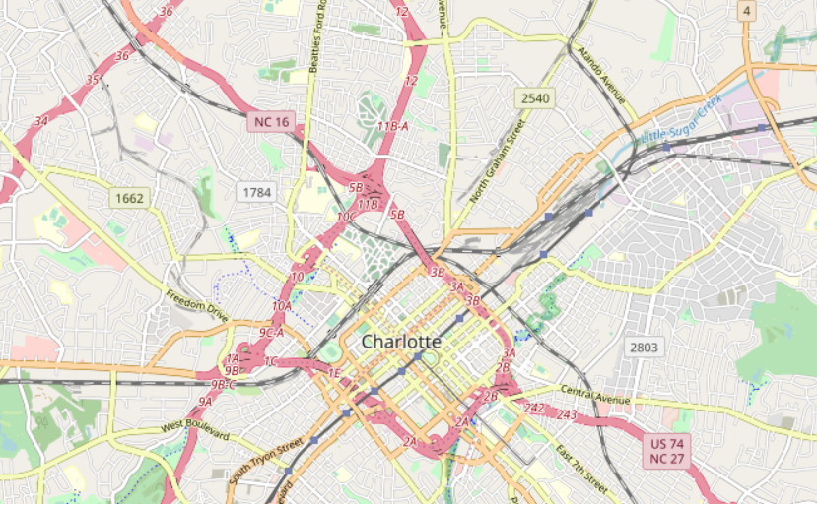

Additionally, there is the fact that we are marketing our business to people who like both Indian Food and Italian food. Hence, we can approach through the lens. In order to understand what would best appeal to the people who like these combinations, I make the assumption that it would be easy to market to potential customers in between an Indian restaurant and Italian restaurant that are located within close proximity to each other. The rationale here is that people who are going to like our potential business will appreciate both of these existing businesses and may be crossing through a part of the city (or already located in this part of the city) where we find our optimal location. If we find a location between two restaurants, one Indian and one Italian, a spot half way between these two geographic locations would be perfect.

I will use Foursquare data to find all of the Indian restaurants within a distance of 10,000 meters to Charlotte city center, which is an area od high population density. Then, I will also use the Foursquare API to figure out which of these Indian restaurants has an Italian restaurant within 700 meters (or closest) to the Indian establishment.

**Results:**

We find variety of Indian restaurants located within 10000 meters of the original given location within Charlotte City Center:

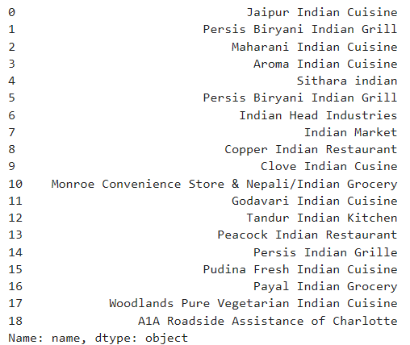

Using this information, I try to run an additional series of commands to find venues nearby to an Indian restaurant (within 700 meters or less). I find that the location with the closest Italian restaurant is Maharani Indian Cuisine. See below:

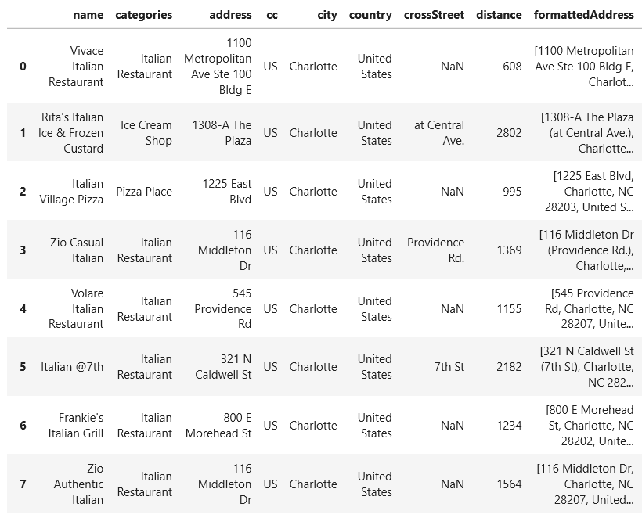

It seems that the best location would be half way between Maharani and Vivace restaurants. This is consistent with what I know if the neighborhoods. Metropolitan is vibrant area with a large customer base which would have the kind of clientele we are looking for.